Q1.

CREATE OR REPLACE FUNCTION CalculateAge(p_DOB DATE)

RETURN NUMBER

IS

v_Age NUMBER;

BEGIN

-- Calculate age based on the difference between the current date and the date of birth

v_Age := TRUNC(MONTHS_BETWEEN(SYSDATE, p_DOB) / 12);

RETURN v_Age;

END CalculateAge;

/

Output:

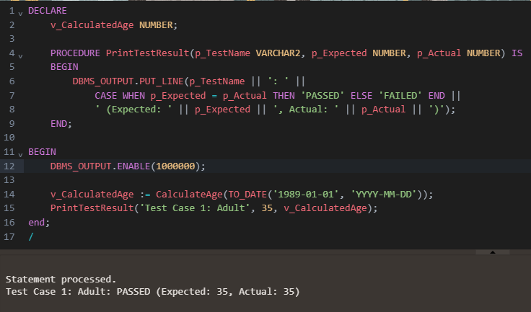

Q2.

CREATE OR REPLACE FUNCTION CalculateMonthlyInstallment(

p_LoanAmount NUMBER,

p_InterestRate NUMBER, -- Annual interest rate as a percentage

p_DurationYears NUMBER -- Duration of the loan in years

)

RETURN NUMBER

IS

v_MonthlyRate NUMBER; -- Monthly interest rate

v_NumberOfMonths NUMBER; -- Total number of payments (months)

v_EMI NUMBER; -- Equated Monthly Installment (EMI)

BEGIN

-- Calculate the monthly interest rate (as a fraction)

v_MonthlyRate := p_InterestRate / 1200;

-- Calculate the total number of months

v_NumberOfMonths := p_DurationYears * 12;

-- Calculate the EMI using the formula

IF v_MonthlyRate != 0 THEN

v_EMI := p_LoanAmount * v_MonthlyRate * POWER(1 + v_MonthlyRate, v_NumberOfMonths) /

(POWER(1 + v_MonthlyRate, v_NumberOfMonths) - 1);

ELSE

-- If the interest rate is 0, the EMI is simply the principal divided by the number of months

v_EMI := p_LoanAmount / v_NumberOfMonths;

END IF;

RETURN v_EMI;

END CalculateMonthlyInstallment;

/

*Output:*

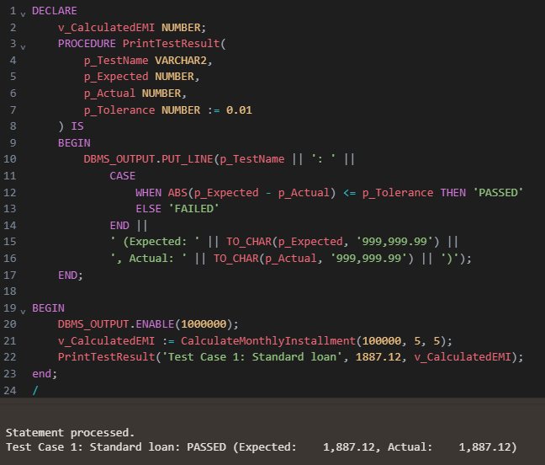

Q3.

CREATE OR REPLACE FUNCTION HasSufficientBalance(

p_AccountID NUMBER,

p_Amount NUMBER

)

RETURN NUMBER

IS

v_Balance NUMBER;

BEGIN

-- Retrieve the balance of the specified account

SELECT Balance

INTO v_Balance

FROM Accounts

WHERE AccountID = p_AccountID;

-- Check if the balance is greater than or equal to the specified amount

IF v_Balance >= p_Amount THEN

RETURN 1; -- Sufficient balance (TRUE)

ELSE

RETURN 0; -- Insufficient balance (FALSE)

END IF;

EXCEPTION

WHEN NO_DATA_FOUND THEN

-- If the account does not exist, return 0 (FALSE)

RETURN 0;

WHEN OTHERS THEN

-- Handle other potential exceptions

RETURN 0;

END HasSufficientBalance;

/

*Output:*

